Nick Layman

Project 2 – Self Pay Kiosk

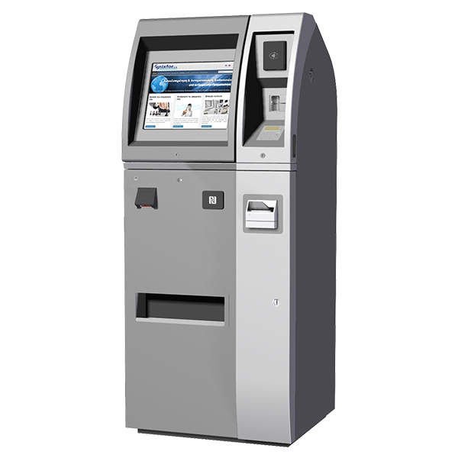

"I pledge that this work is entirely mine, and mine alone (except for any code provided by my instructor).”

X_________________________________

I spent 5 hours working on this project from October 1 to October 7, 2018 reading the assignment, writing the code, fixing errors, writing proper documentation, making the code look more elegant, and making this write up.

